TITLE OF FULL PAPER

Should Concisely and Accurately Specify Subject of Paper (maximum 250 characters with spaces) (Type the title of full paper in 12 pt boldface and in upper case. Use Time New Roman font. It is suggested to use the same title as in the extended abstract that was accepted by reviewers.)

name surname 1*, name surname 2, …

1 Affiliation Institution, Country, E-mail

2 Affiliation Institution, Country, E-mail

* Corresponding author

(Authors’ names are set in 10 pt and in upper case. Affiliations are in 9 pt italics.)

# Abstract (Times New Roman, 11pt, bold)

Abstract should be written in the form of short abstract and should be no more than 200 words briefly specifying the aims of the work, the main results obtained, and the conclusions drawn. Citations must not be included in the Abstract. Use Time New Roman, 11 pt).

**Key words**

keyword 1, keyword 2, … (submit 5 to 8 keywords separated by comma). These should indicate the main subject matter of your paper. Use Time New Roman, 11 pt.

**1 Introduction**

**Main text:** [for clarity of the whole paper and in the scope of scientific papers prepared for the conferences this should be structured using chapter’s titles: Introduction; Methods; Results and Discussion; Conclusion as it is indicated in the text below. Lower level headings could be named optional. **The manuscript may not exceed the 15 pages**

Type the title of the chapter in 12 pt boldface. Type the title of the subchapter (Heading 2, Heading 3) in 11 pt boldface.

The text should be set in 11 pt “Times New Roman”, justified, with a leading (interline spacing) of ‘single’ line spacing. Two single line spacing (11pt) should be left free in front of the title of main headings. One single line spacing (11pt) should be left free in front of the title of sub-headings (Heading 2, Heading 3). One single line spacing (11pt) should be left free between chapter heading (sub-heading) and the main text. It is important to reproduce the spacing of the text and headings as it is explained here and shown below in the text.

New paragraphs are not indented, but are preceded by a line of space.

Please avoid using footnotes..]

Introduction should describe the background of the work and its aims.

**2 Methods**

**2.1 Heading 2 (Times New Roman, 11pt, bold)**

**2.1.1 Heading 3 (Times New Roman, 11pt, bold)**

A brief description of the methods/techniques used (the principles of these methods should not be described if readers can be directed to easily accessible references or standard texts).

Equations should be centered and numbered consecutively, as in Eq. (1).

|  |  |
| --- | --- |
|  | (1) |

Figures can be illustrations or images in color or grayscale. Figures should be a minimum of 300dpi for readability. Number figures consecutively in accordance with their appearance in the text. Please ensure that each figure is correctly scaled to fit the space available (ensure that everything can be read easily). Please avoid the text on figures in less than 9 pt.

Tables should be included in an editable format and not as images. Number tables consecutively in accordance with their appearance in the text and place any table notes below the table body. Be sparing in the use of tables and ensure that the data presented in them do not duplicate results described elsewhere in the article. Please avoid using vertical rules. Tables should be designed to have a uniform style shown in Table 1. Please avoid splitting tables over two pages.

Figure and table captions should be in 10 pt bold. These captions should have as given below.

Table 1. Caption heading for a table should be placed at the top and centered

|  |  |  |  |  |
| --- | --- | --- | --- | --- |
| Parameter | Measumerent unit | Raw wastewater | After pretreatment | After EF/EC treatment |
| Mineral oil | mg/L | 131.1 | 110.3 | 7.6 |
| COD | mg/L | 1,694 | 1,242 | 43 |
| K | mg/L | 10.53 | 2.82 | <0.1 |
| Na | mg/L | 62.77 | 9.21 | 0.72 |

Nores: Notes should be given in Times New Roman, 9pt

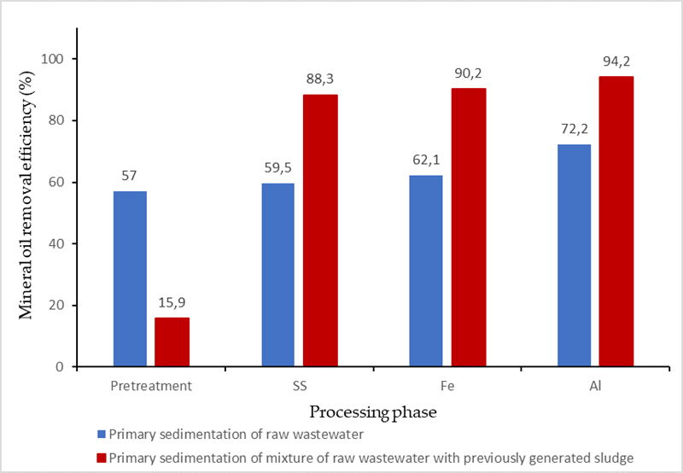

Figure 1. The caption heading for a figure should be placed below the figure, centered. All figures should be correctly positioned within your *docx file.

**3 Results and Discussion**

This chapter should give a clear presentation of experimental results obtained, highlighting any trends or points of interest. It is considered beneficial to give a comparison with the results of similar research activities.

**4 Conclusion**

This chapter should give a brief explanation of the significance and implications of the work reported.

**Acknowledgements (Times New Roman, 11pt, bold)**

A short acknowledgement section can be written here. Use Times New Roman, 11 pt.

**References**

The reference heading should not be numbered. The reference used by the author should be presented at the end of the paper: the reference must not be cited in footnotes. Please ensure that all work cited in the text is included in the reference list, and that the dates and authors given in the text match those in the reference list. References must always be given in sufficient detail for the reader to locate the work cited (see below for formats). Please make sure to cite all references in the paper. The reference should be arranged according to the alphabetical order by the lead author’s last name. Please make sure to include all authors of references.

**Examples of Journal References**

Andrews, J.F. 1993 Modeling and simulation of wastewater treatment processes. *Wat. Sci. Tech.* 28 (11/12), 141–150.

Casey, T.G., Ekama, G.A., Wentzel, M.C. and Marais, G.v.R. 1993 An hypothesis for the causes and control of low F/M filamentous organism bulking in nitrogen (N) and nutrient (N & P) removal activated sludge systems. In *Proc. of the IAWQ First Int. Conf. on Microorganisms in Activated Sludge and Biofilm Processes*, Paris, 27–28 September.

Dold, P.L., Ekama, G.A. and Marais, G.v.R. (1980) A general model for the activated sludge process. *Prog. Wat. Tech.* 12, 47–77.

**Examples of Book References**

Bell J. 2002 *Treatment of Dye Wastewaters in the Anaerobic Baffled Reactor and Characterisation of the Associated Microbial Populations*. PhD thesis, Pollution Research Group, University of Natal, Durban, South Africa.

Henze M., Harremoës P., LaCour Jansen J. & Arvin E. 1995 *Wastewater Treatment: Biological and Chemical Processes*. Springer, Heidelberg.

McInerney M. J. 1999 Anaerobic metabolism and its regulation. In: *Biotechnology*, J. Winter (ed.), 2nd edn, Wiley-VCH Verlag, Weinheim, Germany, pp. 455-478.

Sobsey M. D. & Pfaender F. K. 2002 *Evaluation of the H2S method for Detection of Fecal Contamination of Drinking Water*, Report WHO/SDE/WSH/02.08, Water Sanitation and Health Programme, WHO, Geneva, Switzerland.

*Standard Methods for the Examination of Water and Wastewater* 1998 20th edn, American Public Health Association/American Water Works Association/Water Environment Federation, Washington DC, USA.

**Example of an Online Reference**

Alcock S. J. & Branston L. 2000 SENSPOL: Sensors for Monitoring Water Pollution from Contaminated Land, Landfills and Sediment. http://www.cranfield.ac.uk/biotech/senspol/ (accessed 22 July 2005)

Full paper should be prepared and sent as a *\*.docx* file to the president of the scientific committee of the WSPA2024 Conference (email address: [drazen.vouk@grad.unizg.hr](mailto:drazen.vouk@grad.unizg.hr)) with specific name of the file as follows:

“00-surname-title1-title2-title3.docx”

* 00 = number of selected Symposium Topic (01, 02, 03, 04 or 05)

* surname = surname of the first author

* title1 = first word of the full paper title

* title2 = second word of the full paper title

* title3 = third word of the full paper title